**2.1 Feasibility Study**

The feasibility study is the process of evaluating and analyzing the potential of proposed system. It is based on investigation and research which support the process of decision making. Feasibility study’s objective is to understand the weaknesses and strengths, opportunities and threats in the environment, resources required to establish required system and percentage of getting success. We can say that there are two main factors regarding system development that are cost and time. System analyst has to find out that how much cost new system will consume and how much time it will take to complete it.

**2.1.1 Economic Feasibility**

This part of feasibility study gives the top management the economic justification for the new system. A simple economic analysis that gives the actual comparison of costs and benefits is much more meaningful in such cases. There should be accurate cost and time estimation to develop proposed system within in cost and time with higher accuracy and performance.

In the process of feasibility study, the cost and benefits are estimated with greater accuracy. If cost and benefit can be quantified, they are tangible and if not they are intangible. In the system, the organization is most satisfied by economic feasibility. Because, if the organization implements this system, it need not require any additional hardware resources as well as it will be saving lot of time.

**2.1.2 Technical Feasibility**

The technical feasibility study compares the level of technology available in the software development firm and the level of technology required for the development of the product. System analyst has to find out which tools are required for developing user required product and which tools can fulfill user requirements. System analyst has to determine which technology they are using. According to client product needs organization has to purchase software and hardware tools for better and accurate performance of product being developed.

Here the level of technology consists of programming languages and hardware tools and other tools which are being used by the software development organization.

**2.1.3 Behavioral Feasibility**

The behavioral feasibility study finds out that whether the people want to change the existing manual system to computerized system. People resist because they do not know how to use computerized system. We have to teach people computerized system which will take a long time or they may be unable to understand it. In this case instead of increasing speed and efficiency of system, system’s performance will be decrease.

**2.1.4 Feasibility Report**

The result of feasibility study provides us following facts:

* The system will increase the efficiency of system.
* The system will increase customer’s satisfaction.
* The system will be cost & time effective and reliable.
* The system must have some sort of direct communication between stake holders.

The system should be simple to use and incorporate all necessary services

**2.2 Existing System: Data Gathering**

Zakariyan Educational System Layyah is located at Multan road near by GPO office Layyah. This institution was established in1990.They keep their whole record manually. They maintain the whole record of students, staff and students result manually. This is very difficult for the School organization. Then here, there is a great need to create a system to facilitate the organization to stored their all record electronically. The basic work in analysis phase is gathering and analysis data. Two common data gathering techniques are:

**2.2.1 Questionnaires**

I used both techniques to collect information about the existing system and written materials, and I also used the techniques Participant observation. I visualize them, how they interact with the old existing system. Questionnaires are useful when the analyst need to gather information from a large number of people. It is not possible to interview each individual. If analyst wants to get information in short time then in this case questionnaires are useful. If the analyst guarantees the anonymity of the respondent then the respondent answers the questionnaires very honestly and critically. The analyst should sensibly design and frame questionnaires with clarity of its objective so as to do just to the cost incurred on their development and distribution. However questionnaires do not provide accurate results.

Existing system is based on manual work and all the process are done manually, so they maintain registers and files for recording all the details of the system.

* All the work at the time of admission of the students is done manually by ink and paper.
* Dues form on printed paper is given manually by hand.
* They stored their daily attendance on paper manually.
* They keep the whole record of their staff on register manually.
* They maintain the register or Book for staff so they can pay the salary.
* They make result of their daily test on register manually.
* They required huge staff members for school management.

**2.2.2 Sampling and Observation**

**Observation**

Observations are one of the most effectively tools with the analyst where the analyst personally goes to the site and deeply study the system to discovers the complete functionality of the system. The analyst as an observer can gain knowledge of the activities, operations, processes of the system on that location. Analyst acts as information seeker. This information is very meaningful and accurate as it is has been gathered by the analyst directly. Now analyst can compare information gathered by observing system with information which is documented already. In this way analyst watches the working of system very closely and gets required information. This is time consuming technique because analyst has to visit the site. Analyst observes every component and subcomponent of system to get facts about it.

**Sampling**

Sampling is the process of selecting members or element from a given population. Sampling requires time, money, effort and careful planning. There are two types of sampling: first, probability sampling second, non-probability sampling.

In probability sampling, samples are chosen in such a way that each element of population has a known and usually equal chance of being included in the sample. Sampling is done by drawing lots or through the use of random numbers. Samples are taken randomly from data gathered.

In non-probability sampling, samples are chosen in such a way that some members of population may not have any chance of being included in the sample. Examiners perform transaction testing using sampling procedures which require judgmental or statistical sample. Examiner gathers data using questionnaires and from the manual form of system working and then take some sample. Selected samples are then analyzed using some statistical formulas to gain information about the system under study. Sampling does not gives accurate information about the system.

**2.3 Existing System: Data Analysis**

By thoroughly studying and understanding the existing system that is manually during the   
study I have learnt a great deal of information about the system. There were collected the   
documents and written materials used in that particular system. After Conduction a great   
comprehensive study of the existing system it came into view management of zakariyan educational system.

First step for improving the existing system is to find out the location of errors in the system and causes of errors. Second step is to find out solutions for the problems in the existing system and choose the best possible solution for the improvement of the system. Third step is to find out different ways of applying this solution to the system and then choose the best possible method which can improve performance and reliability of existing system

## **Problems in existing system**

One studying the existing system which is currently functioning manual, many drawbacks have been found. Some of these are follows:

* The existing system is not so friendly because of lengthy and mostly manual procedures.
* In manual system report generation is very difficult. It is difficult to update record manually.
* Any error or mistake discovered in course of work could not be managed easily.
* Records are not maintained in the proper way.

## **Solution**

## The solution to all the problems mentioned above is that there should be such an application software which should be more reliable and run smoothly and must provide following features:

* Software should fulfill requirements of all types of users.
* Software should provide a very efficient way to save and update records in computer systems instead of manual system.
* Software should provide very simple and understandable user interface for project management system. It has to be a user friendly interface instead of a technical interface.
* Software should generate error free reports for all users.
* Software should not struck out or halt.
* Software should provide facility of updating records already existing.

**2.3.1 Data Flow Diagrams (DFDs)**

A data flow diagram is graphical tool used to describe and analyze movement of data through a system. These are the central tool and the basis from which the other components are developed. The transformation of data from input to output, through processed, may be described logically and independently of physical components associated with the system. These are known as the logical data flow diagrams. The physical data flow diagrams show the actual implements and movement of data between people, departments and workstations. A full description of a system actually consists of a set of data flow diagrams. Using two familiar notations Yourdon, Gane and Sarson notation develops the data flow diagrams. Each component in a DFD is labeled with a descriptive name. Process is further identified with a number that will be used for identification purpose. The development of DFD’S is done in several levels. Each process in lower level diagrams can be broken down into a more detailed DFD in the next level. The lop-level diagram is often called context diagram. It consists a single process bit, which plays vital role in studying the current system. The process in the context level diagram is exploded into other process at the first level DFD.

The idea behind the explosion of a process into more process is that understanding at one level of detail is exploded into greater detail at the next level. This is done until further explosion is necessary and an adequate amount of detail is described for analyst to understand the process.

Larry Constantine first developed the DFD as a way of expressing system requirements in a graphical from, this lead to the modular design. A DFD is also known as a “bubble Chart” has the purpose of clarifying system requirements and identifying major transformations that will become programs in system design. So it is the starting point of the design to the lowest level of detail. A DFD consists of a series of bubbles joined by data flows in the system.

**DFD Symbols:**

In the DFD, there are four symbols

* A square defines a source(originator) or destination of system data.
* An arrow identifies data flow. It is the pipeline through which the information flows.
* A circle or a bubble represents a process that transforms incoming data flow into outgoing data flows.
* An open rectangle is a data store, data at rest or a temporary repository of data.

Process that transforms data flow.

Source or Destination of data

Data flow

Data Store

Figure 2.1

**Constructing a DFD:**

Several rules of thumb are used in drawing DFD’S:

* Process should be named and numbered for an easy reference. Each name should be representative of the process.
* The direction of flow is from top to bottom and from left to right. Data traditionally flow from source to the destination although they may flow back to the source. One way to indicate this is to draw long flow line back to a source. An alternative way is to repeat the source symbol as a destination. Since it is used more than once in the DFD it is marked with a short diagonal.
* When a process is exploded into lower level details, they are numbered.
* The names of data stores and destinations are written in capital letters. Process and dataflow names have the first letter of each work capitalized.

**Data Flow**

* A Data Flow has only one direction of flow between symbols. It may flow in both directions between a process and a data store to show a read before an update. The latter is usually indicated however by two separate arrows since these happen at different type.
* A join in DFD means that exactly the same data comes from any of two or more different processes data store or sink to a common location.
* A data flow cannot go directly back to the same process it leads. There must be at least one other process that handles the data flow produce some other data flow returns the original data into the beginning process.
* A Data flow to a data store means update (delete or change).
* A data Flow from a data store means retrieve or use.

**DFD Diagrams Showing Architecture of the Project**

**Level 0 DFD:**

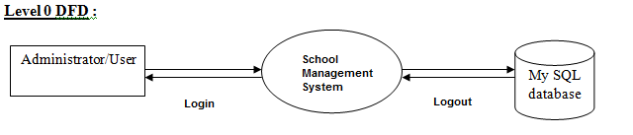

Figure 2.2:Level 0 Diagram for School Management System

**Level 1 Diagram for Admin**

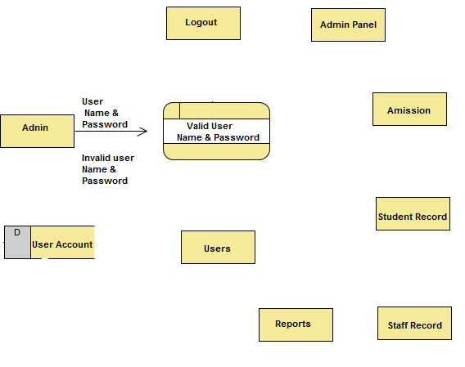

Figure 2.3: Level 2 Diagram for School Management System

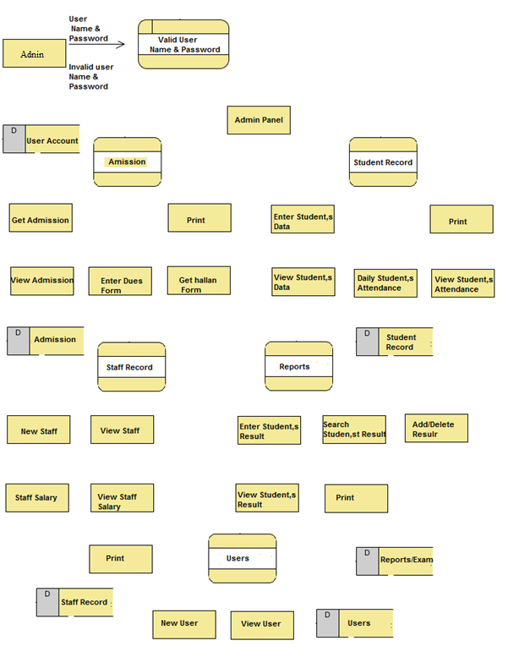

Figure 2.4 Level 2 Diagram for School Management System

**2.3.2 Requirements Engineering**

Methodology in software development means the way to make software. The planning Methodology is consisting of few steps which are given as below.

**Developing the solution design and architecture**:

The development team begins the design process with the solution design and architecture and culminates it with a design document that becomes part of the functional specification.

**Validating the technology:**

The development team also validates technologies to ensure that they meet the business needs for the specific solution.

**Creating the functional specification**:

The project team and Program Management Role create a functional specification that describes the solution requirements, the architecture, and the detailed design for all the features. This represents the contract between the project team and customer.

**Developing the project plans**:

The Program Management Role and the various teams that make up the project team develop a collection of plans to define the tasks for all six MSF team roles, and Program Management consolidates them into a master project plan.

**Creating the project schedules**:

The Program Management Role and the various teams create milestone-driven schedules for each individual team role, and Program Management consolidates them into the master project schedule.

**Setting up the development and test environment**:

The development and test teams create development and testing environments that are independent of the production environment to develop and test the solution.

**Close the Planning Phase**:

The project team completes the Planning Phase with the approval process for the Project Plans Approved Milestone.

**Available Methodology**

**AUP**

Agile Unified Process is a group of software development methods based on iterative and incremental development, where requirements and solutions evolve through collaboration between self-organizing, cross-functional teams. It promotes adaptive planning, evolutionary development and delivery, a time-boxed iterative approach, and encourages rapid and flexible response to change. It is a conceptual framework that promotes foreseen interactions throughout the development cycle. The Agile Manifesto introduced the term in 2001.

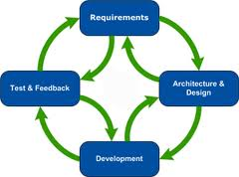

**RUP**

The Rational Unified Process (RUP) is a software engineering framework, created and maintained by the people at Rational Software (now owned by IBM), including Philippe Kruchten. It is a commercial product delivered as a more detailed version of the Unified Software Development Process (which is presented as a generic public domain process). This also means that the RUP suffers from the same problem as the USDP, being bloated and too costly to customize for small projects.

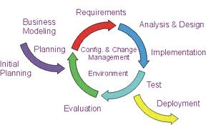

**Water fall**

The waterfall model is a sequential design process, often used in software development processes, in which progress is seen as flowing steadily downwards (like a waterfall) through the phases of Conception, Initiation, Analysis, Design, Construction, Testing, Production/ Implementation, and Maintenance.

The waterfall development model originates in the manufacturing and construction industries: highly structured physical environments in which after-the-fact changes are prohibitively costly, if not impossible. Since no formal software development methodologies existed at the time, this hardware-oriented model was simply adapted for software development

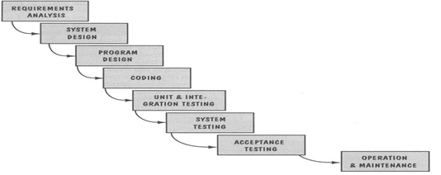

**Spiral Model**

Spiral model is a software development process combining elements of both design and prototyping-in-stages, in an effort to combine advantages of top-down and bottom-up concepts. Also known as the spiral lifecycle model (or spiral development), it is a systems development method (SDM) used in information technology (IT). This model of development combines the features of the prototyping and the waterfall model. The spiral model is intended for large, expensive and complicated projects

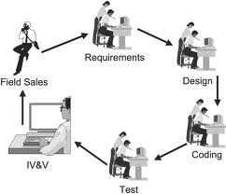

**RAD Model**

Rapid application development (R.A.D) is a software development methodology that uses minimal planning in favour of rapid prototyping. The "planning" of software developed using RAD is interleaved with writing the software itself. The lack of extensive pre-planning generally allows software to be written much faster, and makes it easier to change requirements.

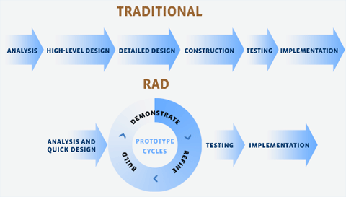

**Chosen Methodology**

I have used Rapid Application Development Methodology in our Project.

**Reason for Methodology**

Rapid application development is a software development methodology, which involves iterative development and the construction of prototypes. It is a merger of various structured techniques, especially the data driven Information Engineering with prototyping techniques to accelerate software systems development. We use RAD Model when Requirements are clear.

**Rapid Application Development Model**

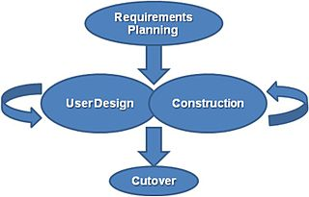

**Advantages of the RAD methodology:**

* Flexible and adaptable to changes.
* RAD generally incorporates short development cycles - users see the RAD product quickly.
* RAD involves user participation thereby increasing chances of early user community acceptance.
* RAD realizes an overall reduction in project risk.
* Pareto's 80 - 20 Rule usually results in reducing the costs to create a custom system.

**Work Plan**

Here is some work plan for SMS in which I defined how I plan to work

|  |  |  |  |
| --- | --- | --- | --- |
| **SR No** | **Activities** | **Days** | **Reason of Durations** |
| 1 | Project/Product Feasibility Report | 2 | Analysis and finding feasibilities which are exists in our Product/project need little bit more concentration by we can judge that what kind of benefits can be obtained to a specific user. |
| 2 | Project/Product Scope | 1 | In scope we concentrate on the limit of area at which our Project/Product facilitating and defined. |
| 3 | Project/Product Costing | 3 | We need the all counts of internal external files. Identifying the files also take more concentration. Calculation of Fi by rating,Cost / FP, Total Estimated Effort, and Total Project Cost involve deep study of project. |
| 4 | CPM - Critical Path Method | 3 | It is a large procedure in which first identifying project activities after that define all activities early start, early finish, late start, late finish and calculation of total slack time and Free slack time. And then finding the critical path by analysis. |
| 5 | Gantt Chart | 1 | I have just entered datain MS Visio application software, because all work for Gantt chart already specify. |
| 6 | Introduction to Team member and Tools and Technology | 1 | We mention just introduction with specific skill set also define tools and technology which we are going to use. |
| 7 | Vision document | 2 | There is need only some more things and description of previous identified parameters of products for generating the Vision. |
| 8 | Risk List | 1 | There is need of finding the uncertainties which can be come in our product/project and they definitely lead to loss also define the approaches to resolve them. |
| 9 | System specification and external entities | 1 | Need analysis according to system specification**.** |
| 10 | Use case descriptions | 8 | First identify the use case name and Description of every single use case according to OOAD. |
| 11 | Use Case Diagram | 5 | Make high level use case diagram and analysis level use case diagram in which we define inclusion, extension and generalization relationships. |
| 12 | Design Class Diagram | 4 | Already identify Classes in domain model .in DCD first identify attributes and function of every class also define relationships among or between classes. |
| 13 | Data Model | 1 | Make ERD using MS SQL server Diagram option |
| 14 | Interface Creation | 18 | Interfaces are easy to use, user can easily interact with our system, and it is really a user friendly system. |
| 15 | Back-end coding | 39 | System is capable of performing its required functionality on demand and without failure system can accomplish its given task accurately and completely according to standard time and cost. |
| 16 | System Testing | 9 | This is the phase which aware us the work need some changes or it meet user requirements or not, If not then what changes are required. |

**2.3.3 Deliverables**

The condition necessary for my project to be deliverable will be that

* It will add new students. It will show the record of entered students. This is my first deliverable.
* It will issue the dues challan form for every students. This is my first deliverable.
* It will add new faculty member. It will show the bio data of every faculty member. This is my first deliverable.
* It will keep the record of employee salary.
* It can enter subject marks. It will make the marks sheet of students. Admin can add more users. This is my last deliverable.